|  |  |  |  |
| --- | --- | --- | --- |
| contact name |  | phone |  |
| company |  |  |  |
| reservation date |  | # of people |  |
| arrival time |  | one bill or separate |  |

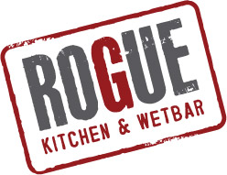

ROGUE BROADWAY

**LUNCH PRE-ORDER FORM**

PHONE: 604-568-9400

EMAIL: roguebroadway@roguewetbar.com roguebroadway@rogUewetbar.com

|  |  |  |  |
| --- | --- | --- | --- |
| Name | APPY | ENTRÉE | NOTES |
|  |  |  |  |
|  |  |  |  |
|  |  |  |  |
|  |  |  |  |
|  |  |  |  |
|  |  |  |  |
|  |  |  |  |
|  |  |  |  |
|  |  |  |  |
|  |  |  |  |
|  |  |  |  |
|  |  |  |  |
|  |  |  |  |
|  |  |  |  |
|  |  |  |  |

*Please email pre-order form by 10:30am for lunch reservations.

*After your order has been sent, call the restaurant to confirm we have received your order and start the countdown to putting work on the back burner and relaxing!

*We do put a 18% auto-gratuity on parties of 8 or more.

THANKS FOR GOING ROGUE!!!!